Tools for hope MAY, 2021 Report
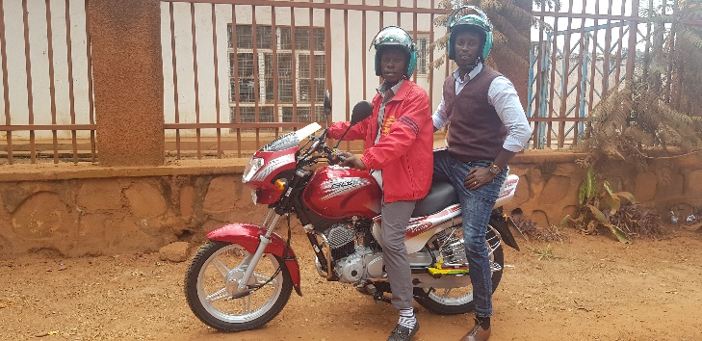 | 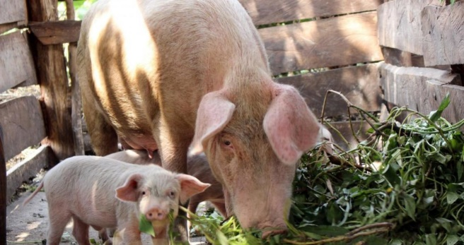
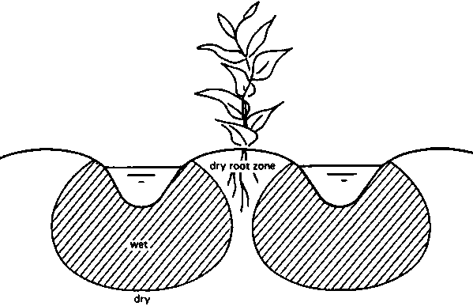 | 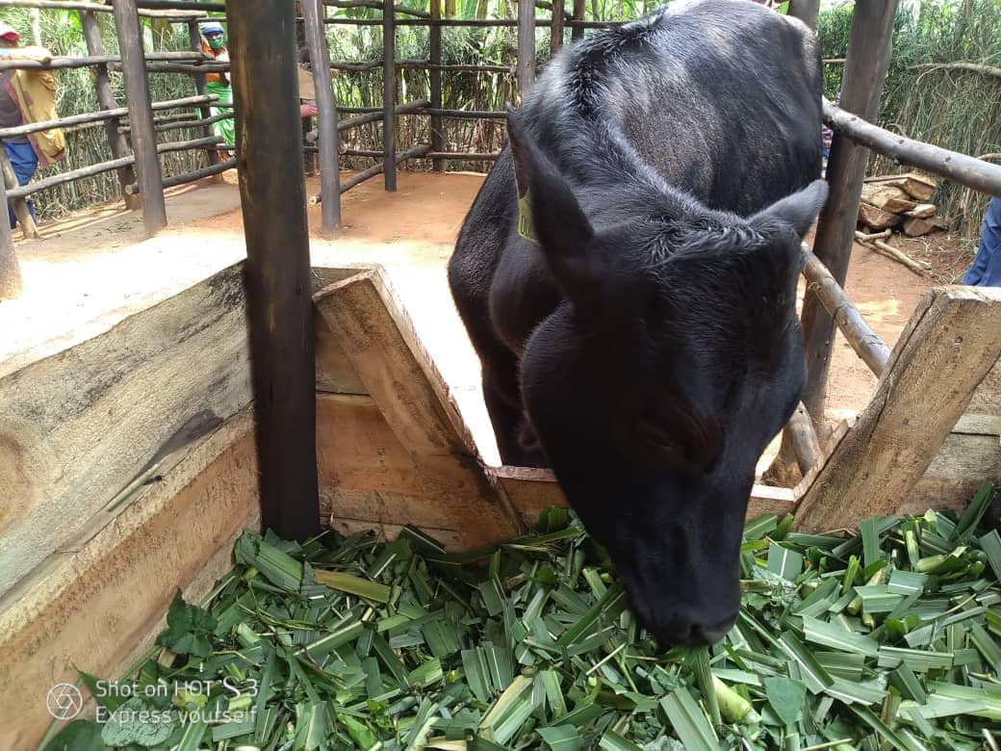

Prepared by
Frank mutesa

MAY, 2021
Training farmers on how to take good care of their livestock and work on how to reduce the Greenhouses Gases Emission from livestock.
Rwanda is among the countries which do really focus on achieving the best alternative ways to reduce greenhouse gases (GHG) emission to the atmosphere. And agriculture is one of the sector which contribute to GHG emission. Some literatures show that emission from livestock account for about 14.5 % of the total GHG emissions globally. The most important greenhouse gases from animal are Methane and Nitrous oxide. These Methane and Nitrous Oxide are produced by enteric fermentation and manure storage. Whereby this Methane is a gas which has an effect on global warming 28times higher than carbon dioxide. It is this regard that we are trying to educate our farmers to make sure and be able to apply some of the methods which store these carbon into the soil (soil carbon sequestration) and make sure they reduce the emission. Working on climate smart agriculture combined with climate smart diary, there is a need to make our farmers aware of different issues and helping them in knowing different techniques as far as the greenhouse gas (GHG) emission, With regards to carbon sequestration.
Therefore we spent much time visiting our farmers and talking to them on how to reduce this emissions coming from their livestock and we decide on few things that they must try to make a move on, of course with our help along the way. Below are some of the practices;
- Feeding livestock based on nutrient needs. By the help of veterinary and agronomists, farmers need to seek for the assistance in testing their forage for nutrients content. And in Rwanda we do have some of the forage that are highly in certain nutrient so we encourage farmers to adapt best forage varieties. We have contacted RAB livestock department where they have different feeding varieties that can help our farmers. By also knowing the nutrient content of their livestock, this will keep them from overfeeding, hence reducing the GHG. Another method to use/ adapt is corn and legume feed which produce less methane than grass. Therefore our farmers can use these corn and legume residues for feeding.
- Implementing manure storage covers/roofs to reduce GHG emission stored in the manure. Therefore we argued our farmers to cover the manure piles with something permanent through the construction by woods and cover them with something strong or they can use straw or hays.
- By the use of composting, this is the easiest and mostly affective method and can be easily adopted by smallholder farmers. We argued farmers to use composting, which is very much indeed reducing GHG release from manure, by making the compounds in the manure more stable. This works by reducing anaerobic activity and increasing aerobic activities instead and hence they can use these compost to the field after proper decomposition.
This picture show the proper cattle barn/house which has all the measures of GHG reduced, because the farmer here is covering all the manure and also use the composting method as well. Therefore this farmer were used to be as good example to others, and also this farmer to takes good care of his cattle by implementing proper cleanness on the barn.
Working on water catchment techniques and preparation for long drought season (June- Early August)
As we are approaching the drought period, farmers need to be vigilant in thinking about how to get possible yield. By now farmers are harvesting their crops and are ready to enter the season c which is known for its long period of drought characterized by lack or few amount of rainfall therefore few farmers do cultivate in this season. What we need to do now is to equip our farmers with good knowledge about how they can apply some useful and effective land management to combat drought stresses from crops. Some of the land use management we argued farmers to adapt are;
- The use of conservation agriculture or the no-till farming system. This simply means, leaving the crop residues on the field after harvesting and also with minimum tillage when sowing. We have done research on this no till farming and farmers are now encouraged to mostly use this methods during drought season.
- Farmers were also encouraged to use the methods of keeping water/moisture in the soil and reduce runoff from the field. This is about the use of mulching and also other farming techniques like furrow and ridges. Also farmers were encouraged to retain the rainwater through different water reservoirs they can afford, like digging hole for keeping runoff water, and catching water from their house tops/roofs.
- Another option is to use native crops varieties or drought tolerant crop varieties. This depends on the crop water requirement of the particular crop, and linking them with weather and climate forecasting info from meteorology agency (METEO- Rwanda) which gives these information in each seasons. Whereby farmers can use the PICSA approach to plan for seasonal agriculture activities.
- The farrow period. This is another way, where you live the land without any disturbance and you live the weeds to grow and give the land chance to regenerate and do cultivate in the next season. Meanwhile you do other non- farming activities.
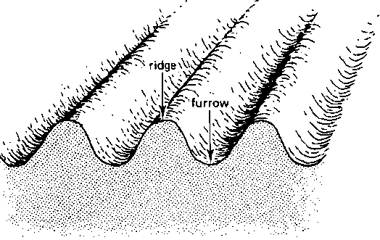
Above is the illustration used to show farmers how this furrow and ridges store water to be used by roots of the crop.
Continuation of the proposed projects and Twisungane responses on different matters raised
We have so far identified some of the projects which can be well managed by Twisungane farmers and which can be paid well without any disturbance. In my previous report, I tried in summary to highlight these project, and here again are listed by their level of priority;
- Motorcycle/transportation business: $ 2800
- Pigs business: $ 1,250 (5 pigs, each will cost $ 250)
- Sewing clothes business: $ 1500 (For 3 sewing machines plus other starter tools)
These are the proposed projects and we had enough time to discuss again and they weigh each project and we come to a conclusion that any of the above can be managed accordingly and even if they get both, we agreed to put representatives to each project and the committee plus myself will be overlooking both projects. Attached to this report, is the bank statement on the motorcycle payment despite the April lockdown in Bugesera but our driver was able to make payments as agreed.
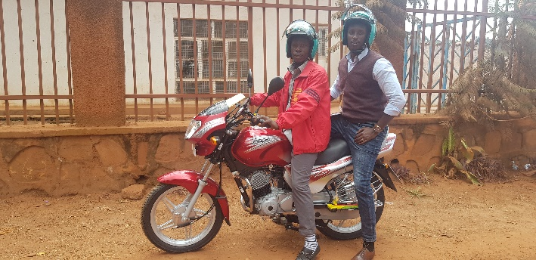
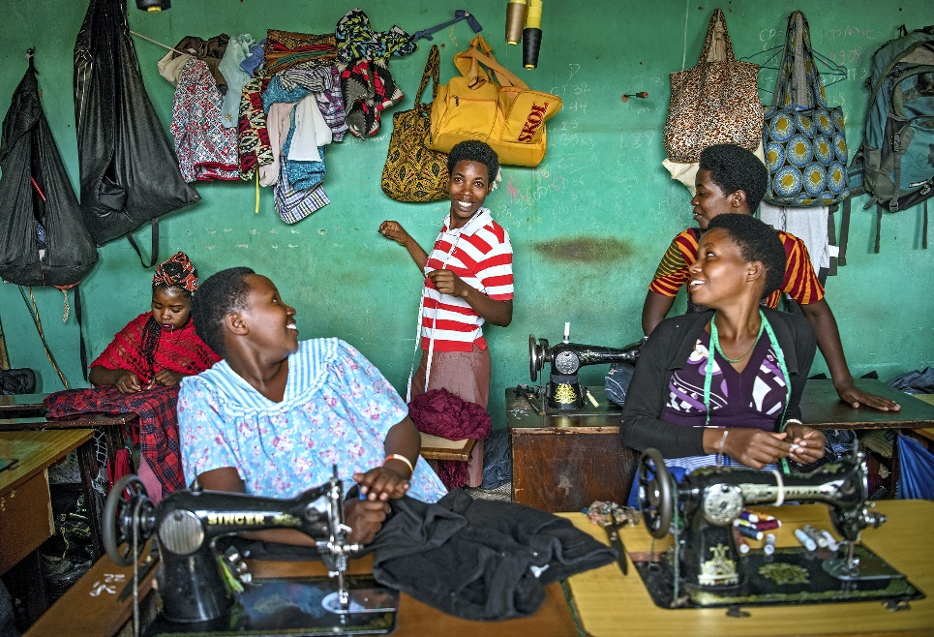
The way forward.
Things are now getting back to normal and farmers are now busy looking here and there on how to best provide for their families and kids are back to school as usual. So the struggle is still on and as always we are keeping them busy and ask them to always think. There are still challenges on how they can work with banks because some of us have no collateral we can use so that banks can gives us enough money to start business so we are still building ourselves and we thank God for TFH who see potential in us and provide whatever they can get without difficult conditions to follow. Thank you once again and may God bless you all.

